DEVA LEGION HOG CHAPTER – OFFICER VACANCIES 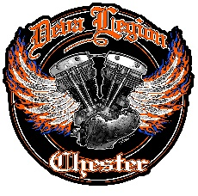

Due to the current officers standing down the following 2 positions are vacant:

Position Vacancy: Safety Officer
Responsible for promoting Safety best practice in chapter activities and events.
This is a committee position. The incumbent should attend committee meetings and fully contribute to shaping the future of our chapter.

Position Vacancy: Ladies Of Harley Officer
Responsible for encouraging female members, whether they ride or not, to take an active part in Chapter events and activities.
Responsible for representing the perspectives and interests of our Lady members.
This is a committee position. The incumbent should attend committee meetings and fully contribute to shaping the future of our chapter.

These vacancies are open to any Deva Legion chapter member and we welcome all applicants regardless. Previous role holders should contact our Chapter Director before applying.
These positions present great opportunities for Deva Legion members to contribute to our Chapter in a bigger way. As part pf our committee you will be expected to fully engage and help shape the future in all aspects of our Chapter.
No previous experience is necessary and we welcome new perspectives and ideas. Your enthusiasm and proactive attitude will be more than enough – and the committee will support you in any needs!

Please contact our Director (Graham) or Assistant Director (Keith) with any questions or to apply.

